One of the deliverables for the Amazon Binary Classification project is a write-up. The goal of this write-up is for you to a) explain what you learned about the data b) describe what processing and modeling choices you made, and c) discuss how your model
performed given your choices. To give you a clearer understanding of what we expect in this write-up, we’ve provided this outline. Your project write-up should include the following sections and information.

Be sure to include your kaggle username and your kaggle team name that appears on the leaderboard.

What is your Kaggle ID? [5 pts]：
Team name：Peijun Qing, Xinyue Liang ：
kaggle username： kris55，lxyskywalker

- Describe the dataset you worked with, including explanations of interesting feature variables and the target variable.
This dataset contains a wide range of information regarding Amazon reviews for various products spanning different product categories. Among each feature within the dataset below, ‘summary’ and ‘reviewtext’ are two most important features for identifying if the text represents a high-star review or a low-star review.
overall: This represents the product's rating on Amazon, and it serves as the basis for creating labels in a classifier.
verified: This indicates whether a review has been validated by Amazon as authentic and genuine.
reviewTime: This is a timestamp indicating when the review was published.
reviewerID: This is a numerical identifier specific to an Amazon user.
asin: It's a unique product identifier; a single product can have multiple reviews associated with it.
reviewerName: The name of the reviewer is provided (though anonymized or encrypted).
reviewText: This feature contains the written content of the review itself.
summary: A concise summary of the review's main points.
unixReviewTime: The reviewTime, represented in Unix timestamp format.
vote: It indicates how many users found the review helpful by voting.
image: This is a link to the product's image, although it might not always be available.
style: Product metadata, potentially describing specific product variations or attributes.
category: The high-level product category to which the item belongs (e.g., Toys, Automotive).
id: An identifier for individual samples within the dataset.

Methods

- Detail the steps you took to process your data
First, we read the data, then take the two most important data as I mentioned above. We concatenate the two text, then we use TfidfVectorizer to convert it into a matrix of TF-IDF features.

- Describe the steps you took to build your model
First I choose three classifiers and define all the parameters that need to be searched, then I directly import packages from sklearn to build the model.

- Describe the hyperparameters you used in your best model. Describe how you did your hyperparameter search.
I use GridSearchCV to conduct search process automatically.

Results

- Show the confusion matrix, ROC, AUC, macro F1 score, and accuracy for the best set of hyperparameters using 5-fold cross-validation for each of your three models.
  - Make sure to show the best model for both Part 1 and Part 2. Thus, you will report each set of metrics twice.
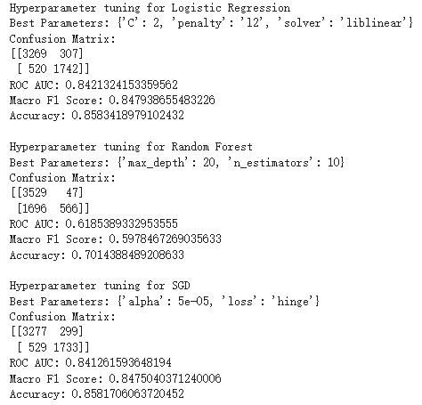
Model | ROC_AUC | Macro F1 | Accuracy | Confusion matrix
LogisticRegression | 0.8421 | 0.8479 | 0.8583 | 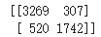
Random Forest | 0.6185 | 0.5978 | 0.7014 | 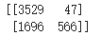
SGD | 0.8412 | 0.8475 | 0.8581 | 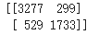
Results from Part 1

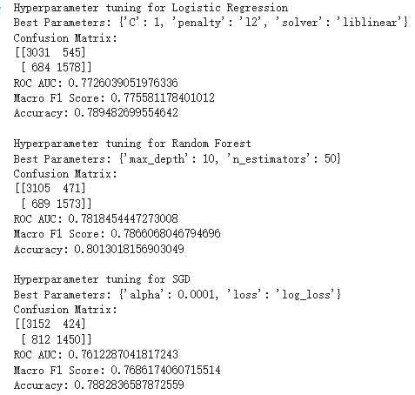
Model | ROC_AUC | Macro F1 | Accuracy | Confusion matrix
LogisticRegression | 0.7726 | 0.7755 | 0.7894 | 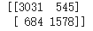
Random Forest | 0.7818 | 0.7866 | 0.8013 | 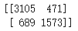
SGD | 0.7612 | 0.7686 | 0.7882 | 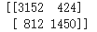
Results from Part 2 (Sentiment Only)
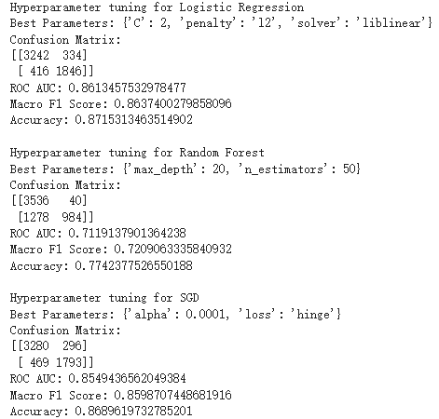

Model | ROC_AUC | Macro F1 | Accuracy | Confusion matrix
LogisticRegression | 0.8613 | 0.8637 | 0.8715 | 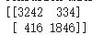
Random Forest | 0.7119 | 0.7209 | 0.7742 | 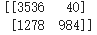
SGD | 0.8549 | 0.8598 | 0.8689 | 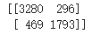

Results from Part 2 (Text + Sentiment)

- Discuss why these metrics are appropriate for this task.
The confusion matrix provides a comprehensive view of the model's performance, allowing you to understand the trade-offs between different types of errors. This is particularly important when dealing with imbalanced datasets or when the costs of false positives and false negatives differ significantly. ROC and AUC are particularly useful for understanding how well the model separates positive and negative examples and for comparing different models. They are appropriate when the balance between sensitivity and specificity is crucial. Macro F1 score is suitable for imbalanced datasets because it doesn't favor the majority class. In the context of product reviews, where the distribution of positive and negative reviews may be imbalanced, it helps assess the model's ability to correctly classify both types of reviews. Accuracy is a widely used metric that measures the proportion of correctly classified examples out of the total dataset. It is a useful metric when the class distribution is relatively balanced, as it provides a simple and easy-to-understand measure of overall model performance. However, accuracy can be misleading when dealing with imbalanced datasets, where a high accuracy may result from a model that predicts the majority class most of the time.

- List the score you achieved using Kaggle

Error Analysis - Sentiment Analysis Model

- Recall from the project instructions “include analysis as to why sentiment is or is not enough to perform amazon review predictions”.
  - Describe why using the sentiment analysis model to predict binary review scores (i.e. using the Vader model by itself with no other information) is a good or bad choice. Support your explanation with at least two examples. That is, look at the correct predictions / errors made by this model and select a few texts to help you in writing your description.
The method involves using Vader sentiment analysis to analyze two features: summary and review text. These analyses are then converted into a sparse matrix and combined with the original dataset. In terms of effectiveness, standalone sentiment analysis has already achieved a respectable level of accuracy. However, when combined with the previously used text vectors, it yields even better results. Relying solely on sentiment analysis may not be the best choice for several reasons. Firstly, sentiment analysis of review text performs approximately 0.1% better than sentiment analysis of summaries (case 1), indicating that sentiment analysis is less effective for short sentences. For example, common phrases like "One Star" in summaries yield a neutral rating of 0.721 (case 2), confirming this observation. When combined with text vectors, the presence of recurring text vectors significantly boosts classification accuracy.

Future Work

- Describe potential future work: what would you do differently next time?

I think next time we could try some large language models .

